DREAMLIFE AFRICA
HOME | ABOUT | PROGRAMS | DREAMFUND | GALLERY | CONTACT

Welcome to Dreamlife Africa’s official website;
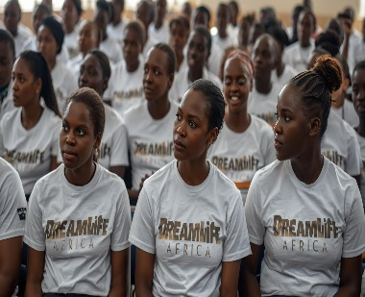 | 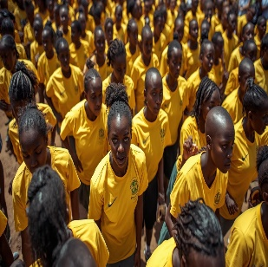 | 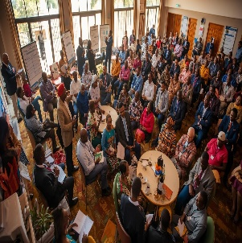 | 
EDUCATION SCHOLARSHIPS | YOUTH MENTORSHIP | LEADERSHIP DEVELOPMENT | WOMEN EMPOWERMENT

“Transforming Lives and Destinies across Africa”

HOME | ABOUT | PROGRAMS | DREAMFUND | GALLERRY | CONTACT

- ABOUT

Dreamlife Africa (DA) is a change oriented, social enterprise whose main purpose is to promote social development, economic stability and fulfillment of dreams across Africa. In pursuance to its core mandate of seeking to increase the hopes and aspirations of African people through shaping mindsets, inspiring dreams and fulfilling destinies, DA partners with churches, Christian ministries, community-based organizations and corporate entities to advance and empower the community through social and economic programs. Since its inception, Dreamlife Africa has;

- Partnered with colleges and given educational scholarships to undeserving college students to pursue their careers.
- Partnered with schools and provided educational scholarships to both primary and secondary schools learners.
- Partnered with music studios and provided grants to many young people to produce their music albums.
- Partnered with friends and well-wishers in the provision of small grants to women in the informal settlements to start small medium enterprises.

- VISION

We envision an outstanding social enterprise that promotes social development, economic stability and fulfillment of dreams on the African continent and beyond.

- MISSION

We exist to increase the hopes and aspirations of people through shaping mindsets, inspiring dreams and fulfilling destinies.

- MANDATE

Restoring quality of life, dignity and honor to all people through holistic transformation; Where folks are intellectually brilliant, socially significant and economic potent.

- FOURFOLD OBJECTIVES

- ENCOURAGING:

Touching members of the community from the low income set ups through giving hope to the hopeless and vulnerable members of the community. We do this by the formation and formulation of Social Support Groups among the communities with the aim of setting up strategies where members within those groups are able to meet their basic needs through a combination of their own income generating activities, access to capital and other financial benefits.

- EDUCATING;

Changing lives through the provision of primary scholarships, secondary scholarships and college scholarships for selected but deserving needy young people in the society. We do this in partnership with primary schools, junior & senior schools and colleges/polytechnics.

- EMPOWERING;

Touching lives through its leadership program by empowering leaders and those aspiring to be leaders in churches, community groups, and organizations through leadership workshops, leadership trainings, and seminars on leadership, financial management and business development among others.

- ESTABLISHING;

Establishing communities through children, teens and youth mentorship, provision of small grants and donations to women and Talent Support to the undeserving but potentially fit young people and women within the society.

- GENERAL SET-UP;

The work of Dreamlife Africa is spearheaded by the Executive Board. The executive board is responsible for strategic oversight, decision making, operational support, performance evaluation, risk management, policy implementation and resource mobilization.

Executive Board Directors

 |  | 
WILLSON MUGAI  Chief Executive Officer  Executive Director | ANNE MUGAI  Executive Director | EINSTEIN MACARTHUR  Non-Executive Director
 |  | 
DOROTHY ROBINSON  Non-Executive Director | DR. SMITH ROBINSON  Non-Executive Director | BRANDON WOODLUCK  Non-Executive Director

HOME | ABOUT | PROGRAMS | DREAMFUND | GALLERRY | CONTACT

- LEADERSHIP DEVELOPMENT:

The leadership development program has two components, namely;

- THE COMPLIT PROGRAM:

Complit is a short form for Computer Literacy. The program’s main aim serves to bring computer literacy to pupils and students across Africa for them to acquire necessary skills in order for them to cope up with the advancing world technology. The Complit program trains teachers on how to integrate Information Technology in their teaching methodologies and thus making education complete.

- THE LEADERSHIP EMPOWERMENT PROGRAM:

Dreamlife Africa through its leadership arm, Dreamlife Africa Leadership Institute, has developed effective leadership empowerment programs to enlighten and empower the leaders who have demonstrated a calling and involvement in leadership. DALI programs are designed to equip pastors, counselors, and Christian workers and community leaders for greater effective leadership.

- YOUTH EMPOWERMENT:

The Youth empowerment program has two departments namely;

- SOCIAL MISSIONS EMPOWERMENT PROGRAM (S.M.E.P):

The main purpose of S.M.E.P is to provide intensive mentorships and career development to young people through Life Skill Workshops, Mentorship Camps and Career Retreats.

- TAMED FOR FAME (T4F):

The main purpose of Tamed for Fame is to identify, nurture, develop and support talent among the young people. Through this initiative, Dreamlife Africa gives upcoming artistes a strong ethical and character development. The arm also, organizes workshops and training for young people aspiring to be musicians, actors, and entertainers.

- WOMEN DEVELOPMENT:

We believe that women can be the most significant catalysts for economic stability and agents in building cohesive societies. By empowering women, we are empowering our societies. It is with this belief that Dreamlife Africa, started the BORESHA MAISHA program under women development. BORESHA MAISHA is a Swahili phrase for “Improve Life.” The program seeks to improve the intellectual, social and economic standards of women through cultivation of leadership skills, enterprise development, business development training, skills training and psychological support. The program is a road map ensuring that ladies are enlightened and empowered on how they can become a dynamic and progressive economic class.

The program involves the following;
- Award Winning Competitions among the women.
- Capacity Building Workshops and Seminars on Leadership, business management, wealth creation, The power of a woman, single parenthood, Raising Teenagers, Groups Dynamics, micro-finance among others.
The BORESHA MAISHA program, with support from friends and partners of Dreamlife Africa, provides small business grants to set up or grow up members’ small businesses in order for them to support their own livelihoods.

In supporting women, we believe as follows:

- An Educated woman is the hope of the society.
- An Enlightened woman is the light for the society.
- An Encouraged woman is the courage of the society.
- An Empowered woman is the power of a successful society.

This program started after it was realized that due to limited funds, Dreamlife Africa through the education scholarship program could not put all the children of financially struggling mothers on scholarship. Dreamlife Africa believes in empowerment of this women and through the empowerment, the women can cater for the other children who are not on the scholarship program. The women became the target after realizing that 90% of women are the ones who attend to Parents School Meetings of their children as compared to men.

YOU CAN CONTACT US THROUGH OUR CONTACT FORM IF YOU WANT TO start a Boresha Maisha GROUP IN YOUR AREA.

“Transforming Lives and Destinies across Africa”
HOME | ABOUT | PROGRAMS | DREAMFUND | GALLERRY | CONTACT


DREAMFUND is a fund that was established and is managed by DREAMLIFE AFRICA whose main purpose is to support orphans and vulnerable children, women, youth and pastors across Africa and beyond. The fund is a common pool for one time and/or continuous donations from friends, partners, organizations, charities and companies across the globe. The main purpose of the fund is to help applicants of the fund to be self-sustainable, self-reliant and fulfill their dreams. The fund is in form of scholarships and grants.
The fund is a consolidated fund comprising the following support;

- education scholarship: This is an educational support that caters for payment of school fees for primary, secondary and college/polytechnic pupils and students.

- BORESHA maisha BUSINESS SUPPORT: This a fund established for the support of women running small medium enterprises (SMEs).

- TALANTA INITATIVE SUPPORT: Talanta (A swahili word for Talent) support is a financial support established for the support of talented young people.

“Transforming Lives and Destinies across Africa
HOME | ABOUT | PROGRAM | DREAMFUND | GALLERY | CONTACT

 | 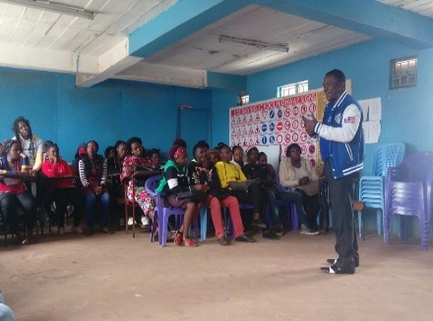 | 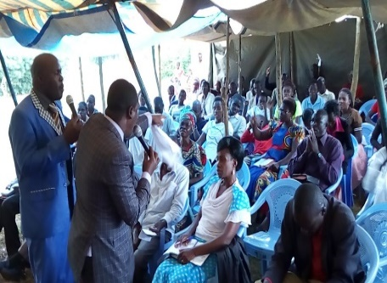 |  | 
Leadership Summit | College Mission | Clergy Summits | Sponsored Students | Women Empowerment
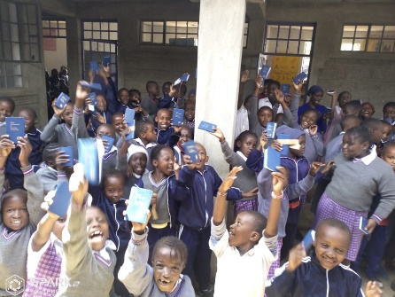 |  | 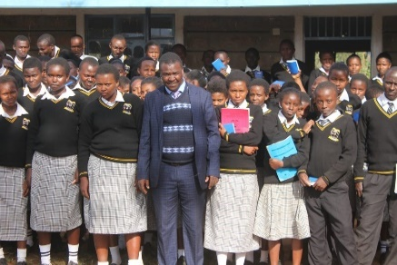 |  | 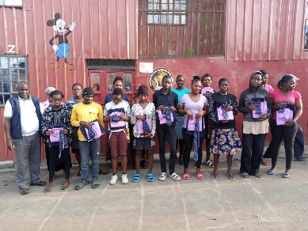
Bibles Distribution | Sponsored Youth | School Mission | Business support | Uniform Distribution
 | 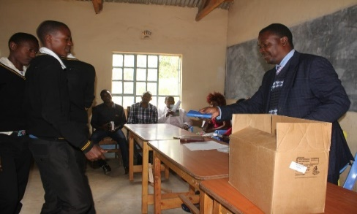 | 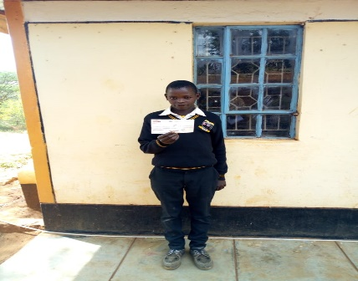 |  | 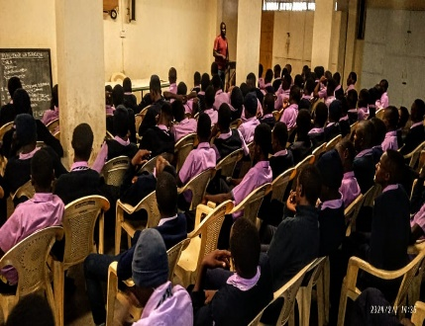
Artiste Support | Books Distribution | Education Bursary | Talent Bursary | Boys Mentorship
 | 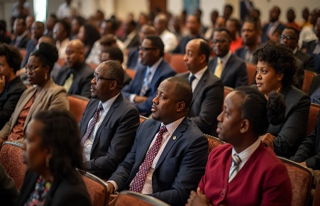 | 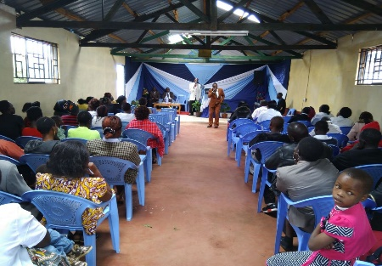 | 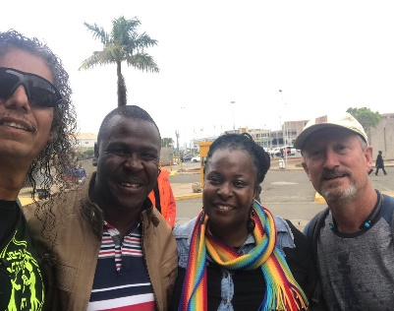 | 
Women Workshop | Leadership Conference | Leaders’ summit | Dreamlife friends | Business Support
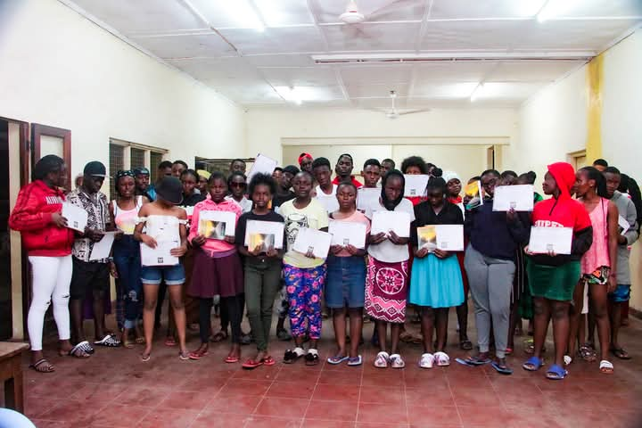 | 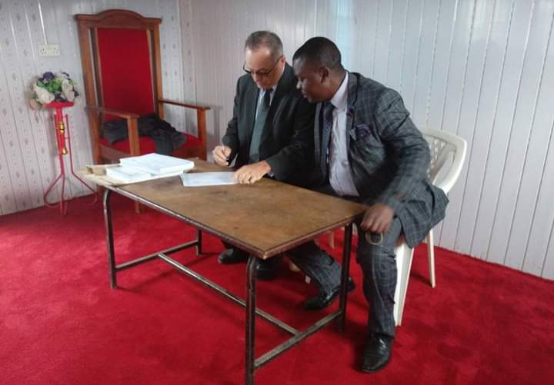 |  | 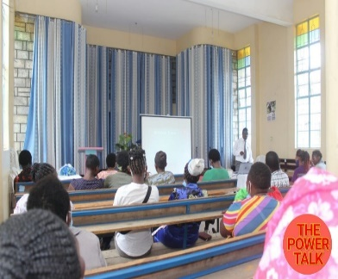 | 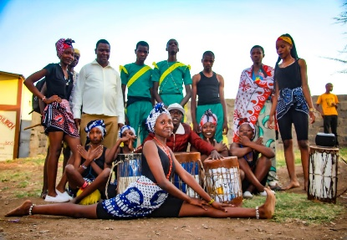
Mentorship Camp | Certificates Signing | Leaders’ Summit | Leadership Workshop | Youth Support

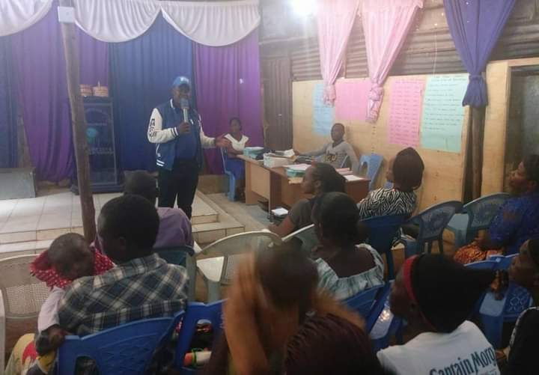 | 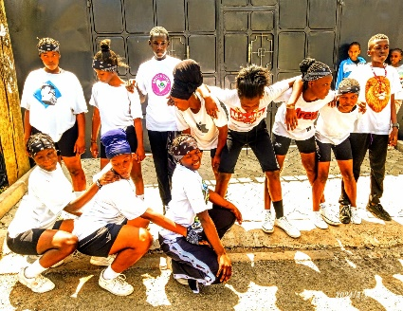 |  | 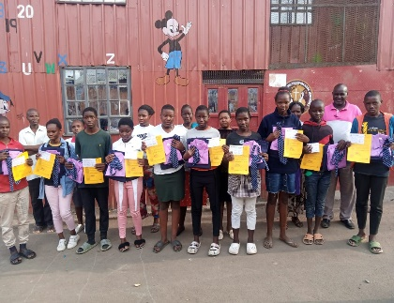 | 
Women Training | Dance Group Support | College Bursary | Secondary Bursaries | Theological Bursary

HOME | ABOUT | PROGRAMS | DREAMFUND | GALLERRY | CONTACT

CONTACT US

HEAD OFFICE  Dominion Centre,  Along Kangundo Road,  Tel: +254 721 657 845  +254 710 331 770 | REGIONAL OFFICE  Eastland offices.  Next to Goldenlight Academy,  Mother Terressa Road, Huruma.  Near Daniel Comboni Catholic Church. | CONTACT  - Administrative Issues: admin@dreamlifeafrica.org  - Chief executive’s contact: willson@dreamlifeafrica.org

OFFICE HOURS

Monday – Friday: 8AM – 4PM (EAT)
NB: The offices remain closed on Saturdays, Sundays and during Kenyan public holidays.

CONTACT FORM.

